Initial version of PDU was defined by the **RFC 1157** as part of the SNMP version 1 standards which are now historic.

An improved version of these PDU redefined later as part of second version of SNMP standards (**RFC 3416, 3417**). Since both versions are widely used.

Latest version of SNMP is version 3 which adds some security features but made no changes in PDU definitions.

Kinds of PDU’s

1. GET pdu

* It is used by the manager to read information from the Agents

1. SET pdu

* Modify the information within the agents.

1. GetNext

* Also reads the info from the Agent, it does not need to know the precise identifier of the managed Object(like KPI’). So, it is ideal for the information about which MIB object the Agent support or the dynamic information like tables that dynamically change its size.

1. GetBulk

* Ideal to retrieve the large amount of data.

1. Trap

* Singals special events to the manager. The manager will not acknowledge reception of the trap which means the agent cannot be sure that the manager received the trap.

1. Inform

* It is same as that of the Trap but acknowledges the Manager.

1. Report

* Internally used by the SNMP protocol to signal protocol exceptions. It is not directly used by the management applications.

Variable Binding:

The combination of Object Identifier and Object Value is called Variable Binding.

Variable Binding = Object Identifier + Object Value

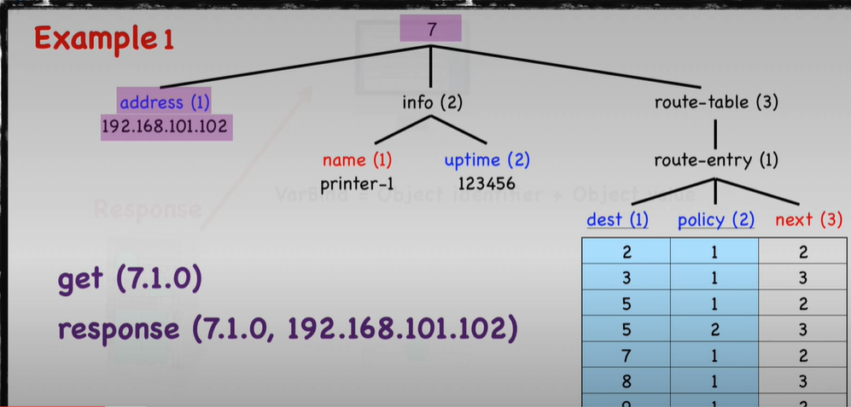

Here OID is 7.1.0 which the manager sends along with the GET PDU and sends back the response PDU. This response contains Variable binding i.e, OID+value. In real time there will multiple variable bindings the agent will send for example sysuptime.

